Using 3D Slicer to create 3D brain models and movies

Jazlynn Langworthy

**3D SLICER: AUTOMATED**

https://github.com/jazlynn21100/PrettyBrainSegmenter/blob/master/3D%20segments%20using%203D%20Slicer

**A lot of the following information is obsolete due to the slicer automation that I have completed (linked above)**

**To use the automation:** You will need to turn on the python interactor in the top right-hand corner of slicer (Shown in red in figure 0), after changing the path to be where the images you are interested in are located, you can copy and paste the code into the interactor to have a pretty brain!

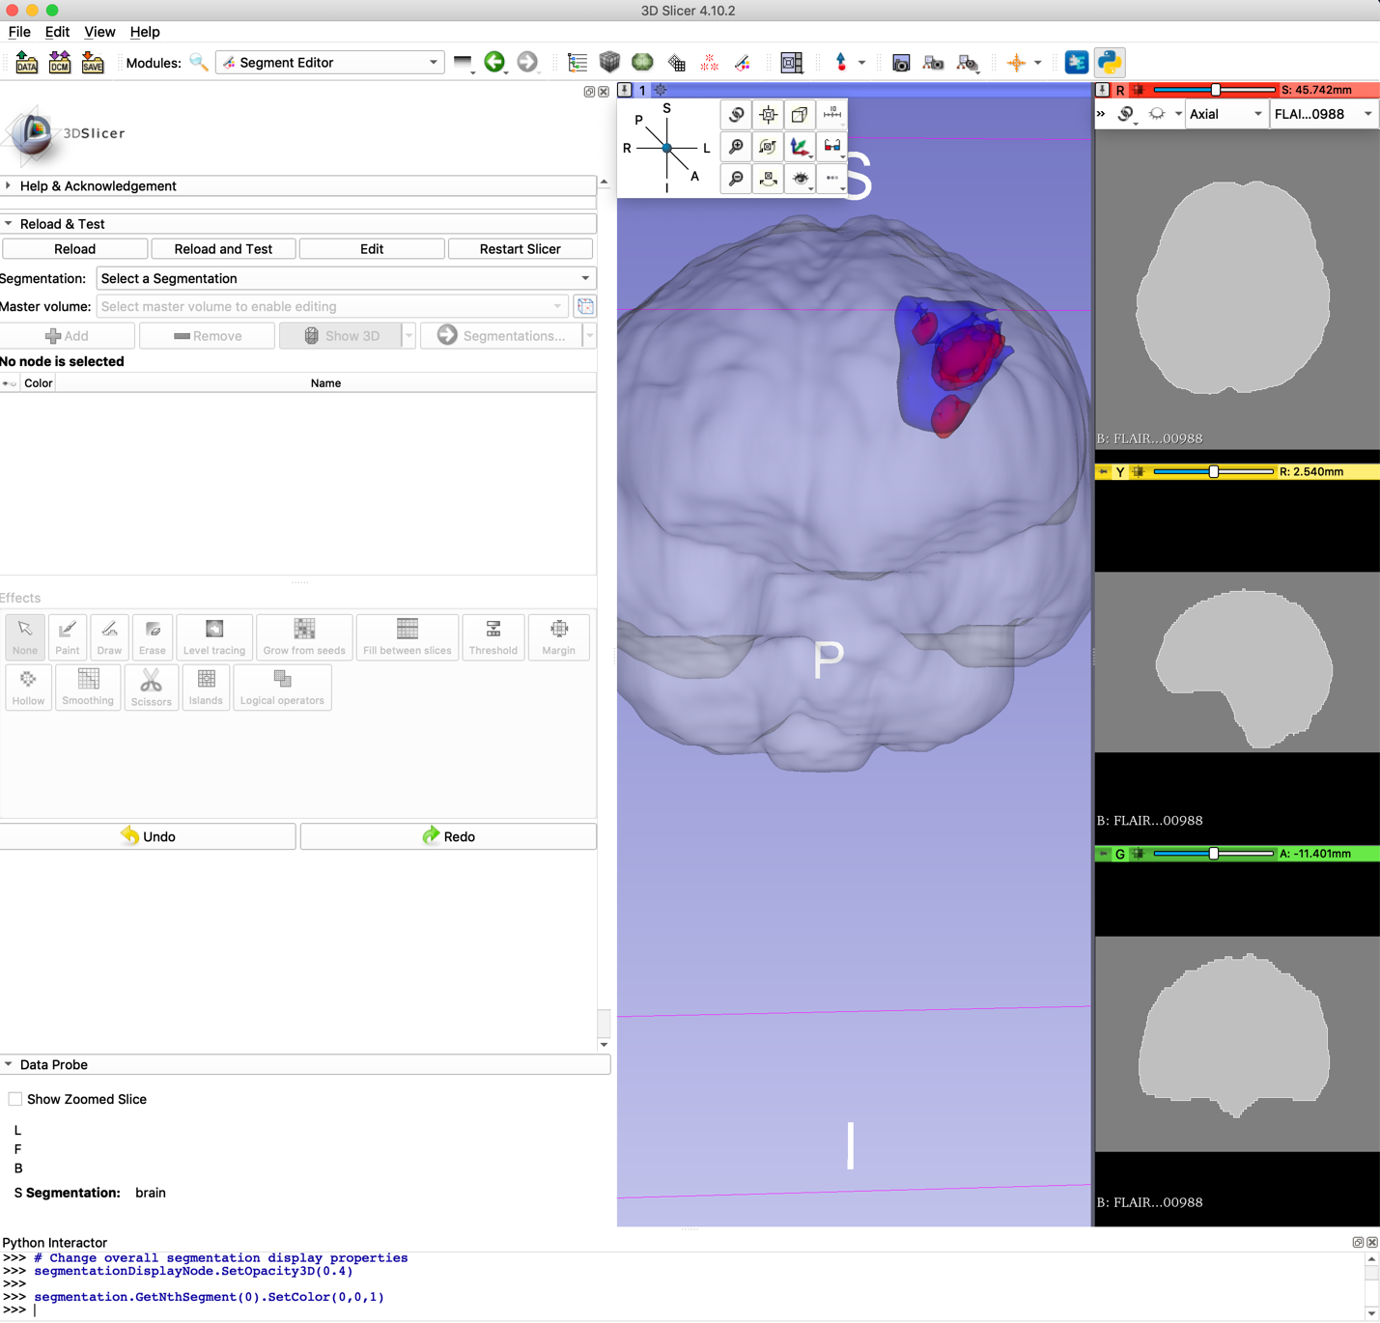

**TABLE OF CONTENTS**

1. Already Created photos and videos
2. Continuity
3. Creating 3D models using ‘Models’

**3.1** Your will need

**3.2**  Editor

**3.2.1** Starting point

**3.2.2** Mask

**3.2.3** Using MRIs

**3.3** Robust Statistics Segmenter

**3.4** Model Maker

**3.5** Models

**4.0**  Creation of biopsies

**4.1** You will need

**4.2** Editor

**4.3**  Model Maker

**4.4**  Models

**5.0** Creating 3D models using ‘Segmentations’

**5.1** You will need

**5.2** Segment Editor

**5.2.1** Mask

**5.2.2** Using MRIs

**5.3** Segmentations

**6.0** Making a brain movie

**6.1** You will need/ basics

**6.2** Showing creation of models

**6.3** Putting scenes together

**6.4** Slowing things down

**6.5** Transitions and titles

**6.5.1** Multiple titles

**6.5.2** Watermark

**6.6** Making Progression Movies

**7.0** Saving Models Correctly

**8.0** Documentation/ the Forum

**1.0 Already created photos and videos**

As of 07/26/2019, the location of the photos and videos is in the S Drive, under current members, in the Jazlynn folder, within that folder you will find a folder called ‘3D slicer’ there will be folders with patient identification on them, and within that you will find 2 more folders, one with photos, one with videos, and a ‘model information’ sheet

**2.0 Continuity**

**Colors:** for future reference: t1Gd is red, T2 blue and biopsies yellow because of how these regions are usually graphed, it will make more sense in analysis

Organization of a brain images folder: the first folder should be marked with the patient ID, inside that folder should be three things, information about the patient, and 2 more folders, one entitles brain images, and one entitle brain videos to try and keep things as organized as possible. You can also include all of the saved model stuff into this folder so that everything is in the same place ☺

Opacity: I did 0.2 for the brain, 0.3 for the T2 and 0.4 for the T1Gd region, and then finally 0.9 for the biopsies, although this is all up to personal preference just like with a lot of this stuff

**3.0 Creating 3D models using ‘Models’**

If you want to go the way of using models, you may be using the editor tab, the robust statistics segmenter, model maker, and finally the models tab

**3.1 YOU WILL NEED**

To create the models this way, there are two options, a mask option and an MRI option

For the mask option, you will need the brain and ROIs to be masks already (nifty files)

For the MRI option, depending on your ROIs you will need the T1Gd and T2 MRIs

**3.2 EDITOR**

**3.2.1 STARTING POINT**

1. To create a model, go to the editor tab first (look under all modules)
2. Pull in the T1Gd and/or T2 image for the patient you’re looking at
3. make the master volume the T1Gd image (You will get a pop-up window about colors, and you can choose to change them or keep them the same, it doesn’t really matter either way)
4. Click ‘Per-Structure Volumes’
5. Click ‘Add Structure’ and choose whatever you want for the structures, but for something that’s easy, I named them ‘brain’ ‘edema’ and ‘mass’ for the brain mask, T2 region and T1Gd region respectively

Now it’s time for creation!

**3.2.1 MASK**

1. Click the volume that you want to go first (you should see on the bottom half of the screen that the label will change to whatever you named your label, shown below in red on figure 1)
2. Pull in the ROI that you’re interested in creating and click the ‘Threshold Effect’ button, circled in blue on figure 1)
3. Set the range from 1-1 so the mask is chosen, and press apply
4. Repeat steps 1-3 for all ROIs
5. Go to the ‘Model Maker’ section of the instructions!

**3.2.2 USING MRIs**

1. Press the pin in the upper left hand corner of any of the viewers, and hit the rings so they are connected to link the images
2. Click the volume that you want to go first (you should see on the bottom half of the screen that the label will change to whatever you named your label, shown in figure 1 in red)
3. Choose ‘LevelTracingEffect’ (circled in yellow on figure 1)
4. Go through each slice of the MRI, using the effect to fill in your entire region of interest (if you would like to see it as an outline rather than a fill, press the pin and hit the button next to the name of your master image (shown in figure 2), if you don’t care about the image being prefect, you only need to outline a few slices, then move on to the robust statistics segmenter section of the instruction

**3.3 ROBUST STATISTICS SEGMENTER**

1. The parameter set option doesn’t need to change
2. Set an ‘Approximate Volume’ (this does not have to be anywhere near perfect); you can set the brain to be about 1500, and assume volume based on that number and the images what the tumor volume may be (the assumed volume isn’t critical, the module is pretty smart)
3. Auxiliary Parameters can be set however you see fit, but when I was using it I would set ‘Intensity Homogeneity’ to 0.3 and ‘Boundary Smoothness’ from anywhere between 0.5 and 0.7
4. Under ‘IO’ the ‘original image’ is the image that the label is created on (the same original/master image as editor) the ‘Label Image’ is the label that was just created in the editor tab, for the output volume, choose ‘Create new output volume as…’ and name the volume whatever seems fitting
5. Press apply!
6. Go on to model maker

**3.4 MODEL MAKER**

1. Parameter set: it will automatically be ‘model maker’ and that’s fine, no need to change it unless you have multiple parameter sets you’re interested in
2. Under ‘IO’ the input volume should be what you created in the step before this (mask: mastervolumename-region-label//using MRI: whatever you named the segmentation)
3. Models: create a new model hierarchy (you only have to do this once)
4. Name your model, then open the ‘Model Maker Parameters’ drop-down menu!
   1. Smooth: 30
   2. Filter Type: Laplacian
   3. Decimate: 0.1
   4. Click ‘apply’

**Obviously you can play with these values however you see fit to work with what you’re working on**

Yay! A model! Repeat the steps for more models! And move onto models for the next step

**3.5 MODELS**

1. Click the model that you’re interested in, lower the opacity under 3D Display
2. Change the color under visibility
3. Change the way you see the model under 3D Display: Representation (ooh fun)

**4.0 THE CREATION OF BIOPSIES**

this will be done using the editor, model maker, and models tabs

**4.1 WHAT YOU WILL NEED**

Until we have a better way of creating the biopsies, you are going to need the biopsy location screenshots from surgery to create the biopsies. You will also need to T1Gd or the T2 (whatever the screenshots are taken on, most likely T1Gd).

**4.2 EDITOR TAB**

1. Set the master volume to be the image that matches the screenshot (T1Gd most often)
2. Under edit selected label map, choose the ‘Paint’ tool (circled in purple on figure 1)
3. Choose the color that you want for the biopsies (I used ‘autonomic nerve’ which is a bright yellow color)
4. Set the radius to be 4mm (just type it in the box)
5. Under the radius bar, click the sphere box so it is checked
6. Using the screenshots from surgery, match the slices, and add each biopsy as closely as possible to the actual image (just put your 4mm dot where the image is pointing and let slicer do the rest, don’t try to go slide by slide, just one dot per biopsy)

**4.3 MODEL MAKER**

1. Parameter set: it will automatically be ‘model maker’ and that’s fine, no need to change it unless you have multiple parameter sets you’re interested in
2. Under ‘IO’ the input volume should be the label that you created in editor
3. Models: create a new model hierarchy (you only have to do this once)
4. Name your model, then open the ‘Model Maker Parameters’ drop-down menu!
   1. Smooth: 30
   2. Filter Type: Laplacian
   3. Decimate: 0.1
   4. Click ‘apply’

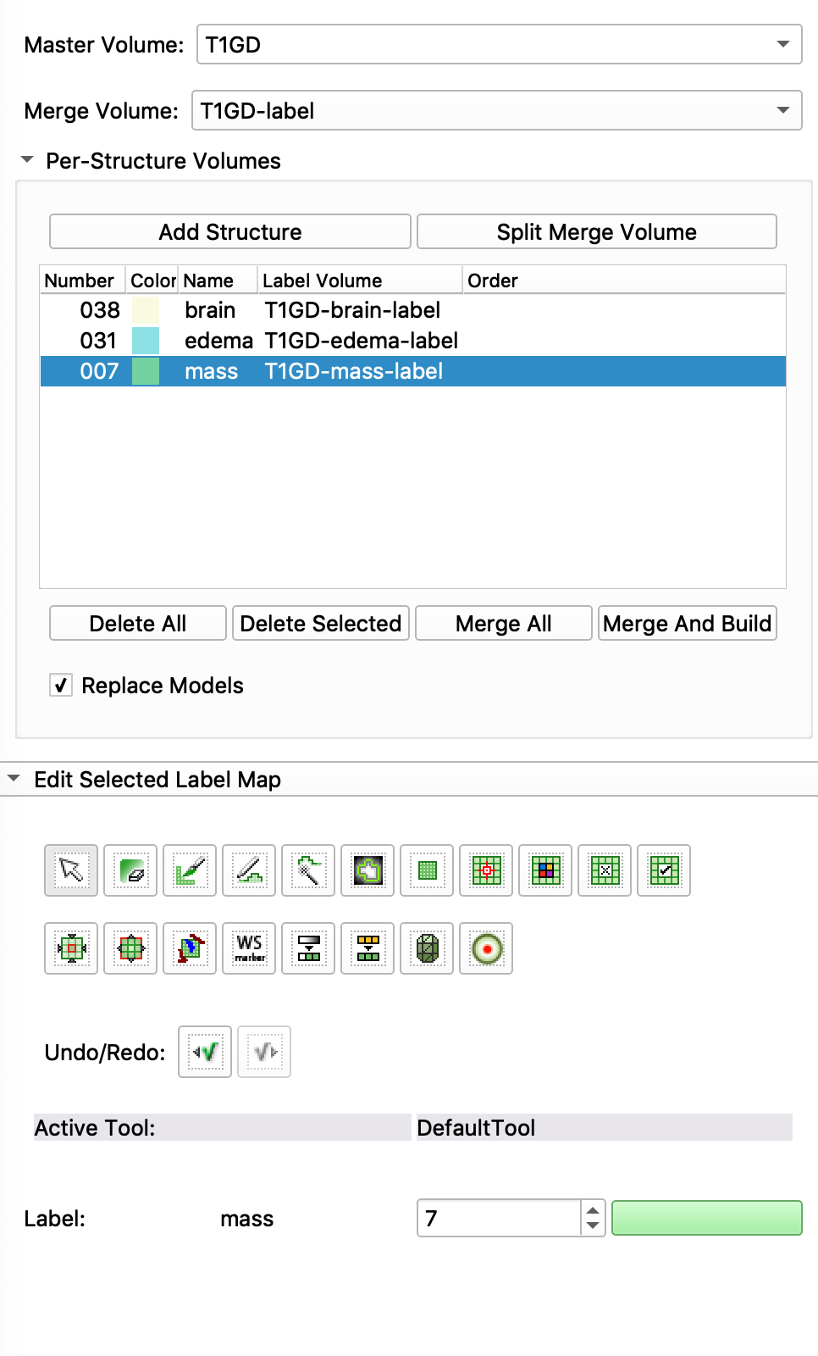

The chosen label should match in the editor section

Figure 1. Editor Tab

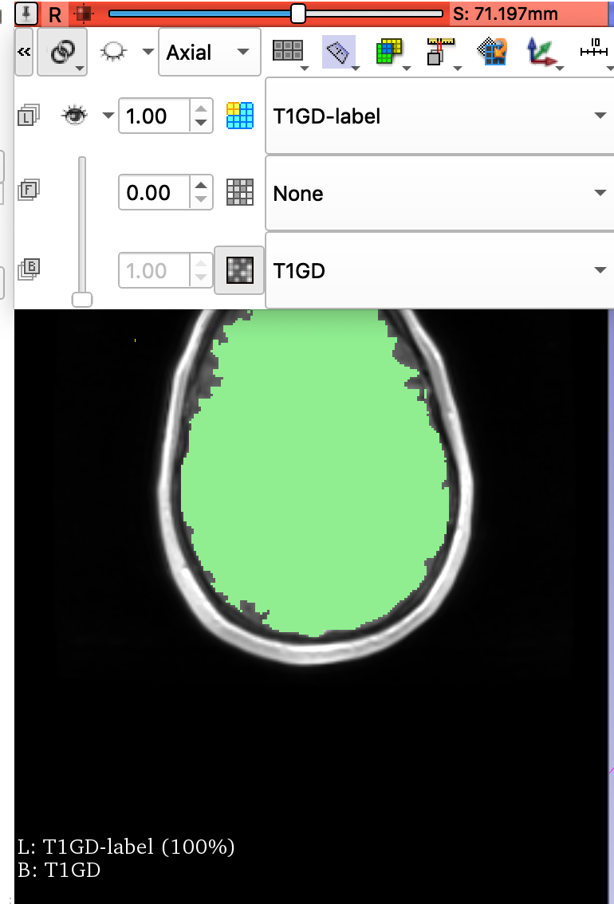

View the ROI you are drawing as an outline rather than filled

Link viewers!

Figure 2. Brain Masking

**4.4 MODELS**

It is good to set the opacity to 0.9 instead of 1, since in certain situations, the 0.9 will actually show up better on slicer that the 1 will! (This is the first bar under 3D display)

**5.0 Creating 3D models using ‘Segmentations’**

If you are going to go the segmentation route, you are going to be using segment editor and segmentations!

**5.1 WHAT YOU WILL NEED**

To create the models this way, there are two options, a mask option and an MRI option

For the mask option, you will need the brain and ROIs to be masks already (nifty files)

For the MRI option, depending on your ROIs you will need the T1Gd and T2 MRIs

**5.2 SEGMENT EDITOR**

**5.2.1 MASK**

1. Load all of your images
2. For each of the overlapping areas that you want to create, you will need to make a new segmentation
3. Once you make a new segmentation you’re going to want to choose a master volume related to the segmentation (like if segmentation_1 is for T1Gd, set the master volume to the T1Gd mask, for ease of use), press the ‘add’ button, and choose the details of your segmentation
4. Under effects, choose threshold if you have a mask when you choose threshold, since it is a mask, set the low and high both to 1 to choose the masked area
5. Apply this and choose show 3D to see what it looks like
6. Move onto segmentations tab

**5.2.2 USING MRI**

1. Load all of your images
2. For each of the overlapping areas that you want to create, you will need to make a new segmentation
3. Once you make a new segmentation you’re going to want to choose a master volume related to the segmentation (like if segmentation_1 is for T1Gd, set the master volume to the T1Gd mask, for ease of use), press the ‘add’ button, and choose the details of your segmentation
4. Under effects, choose Level Tracing if you do not have a mask, and try to match the filled in region to your region of interest to the best of your ability, making sure to get every slice
5. Apply this and choose show 3D to see what it looks like
6. Move on to segmentations tab

**5.3 SEGMENTATIONS**

1. Choose the segmentation that you want to edit under ‘Active Segmentation’
2. Change opacity under display > 3D
3. There’s probably lots of other fun stuff to play with in this module

Obviously, you can play with whatever you want and you realistically might find a better way to do it than I have found!

**6.0 MAKING FUN BRAIN MOVIES IN IMOVIE**

**6.1 WHAT YOU WILL NEED/BASICS**

This part of the tutorial uses iMovie 10.1.12

You can make the brain do whatever you want, but I’m going to explain how to do the basic stuff to make life easier so you don’t have to look too far.

Screen recording shortcut (Mac): shift + command + 5

Screenshot shortcut (Mac): shift + command + 4

My recommendation is that you already have everything set up exactly how you want to record it! You’re going to want to set a screen that is short and long (like a movie theatre screen, so that when you make the movie, you don’t have to crop it) you don’t want to move it from the is position the entire time you are recording the video, because it will make it much easier to put together in the end

I recommend taking videos with a black background, and if you want to take screenshots to use in a powerpoint or something like that, to use the white background! (Getting different backgrounds shown in figure 3)

You can record the brain doing absolutely whatever you want, but see figure 3 for some useful tips as far as buttons go

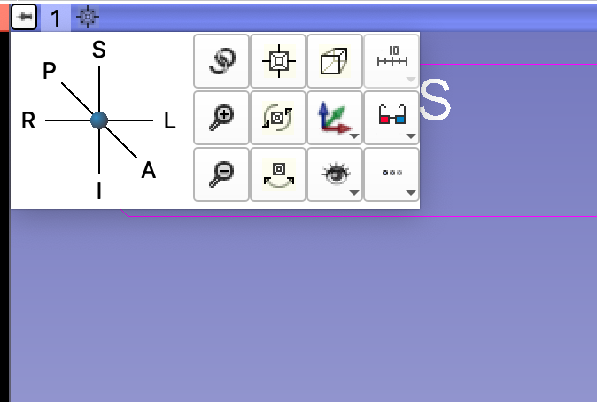

This left side controls model orientation

These 2 boxes are different ways to rotate your 3D object which looks great in videos

This will give you the ability to get rid of the axis labels, the 3D box, and change the background color

Figure 3. 3D orientation

**6.2 SHOWING CREATIONG OF MODELS**

Make sure that the slices are not connected for this piece, and choose the slice that you want to use, and press the eye so that you can see it in the 3D viewer and scroll through it

Go to either the segmentations or the models tab, depending on how you made it, lower the opacity to 0 so that you can’t see the models, and when you are recording, step through it to show it being “made”, but only put it up to where you had it before so you can see all of the ROIs together or whatever TIP: you can click on the area that you would type the number and use the arrow keys to move by 0.1 (hold it down to make it as smooth as possible, but it’s still pretty choppy)

Once you have the model in place, you can move the MRI sliced through it, and you’re really see how well it fits, which is really cool, but if you did a more approximated version, I wouldn’t really recommend doing this, because it’s not going to be as exact and won’t look as good going through the MRI

**6.3 PUTTING SCENES TOGETHER**

Once you have completed making all of your wonderful video clips, or in the middle of making them, it really doesn’t matter, you’re going to open up iMovie, which is an application that all mac computers come with

Pull the videos in in the order that you want them to come up

Some of the clips may involving moving the picture around so that they match, and to do that, when you have the video selected, press the little crop button on the top toolbar and move it as you see fit, however, you probably don’t want ken burns, because that’s a panning thing, so it will zoom the image in or out depending on how you set up your windows, which you may or may not want (figure 4)

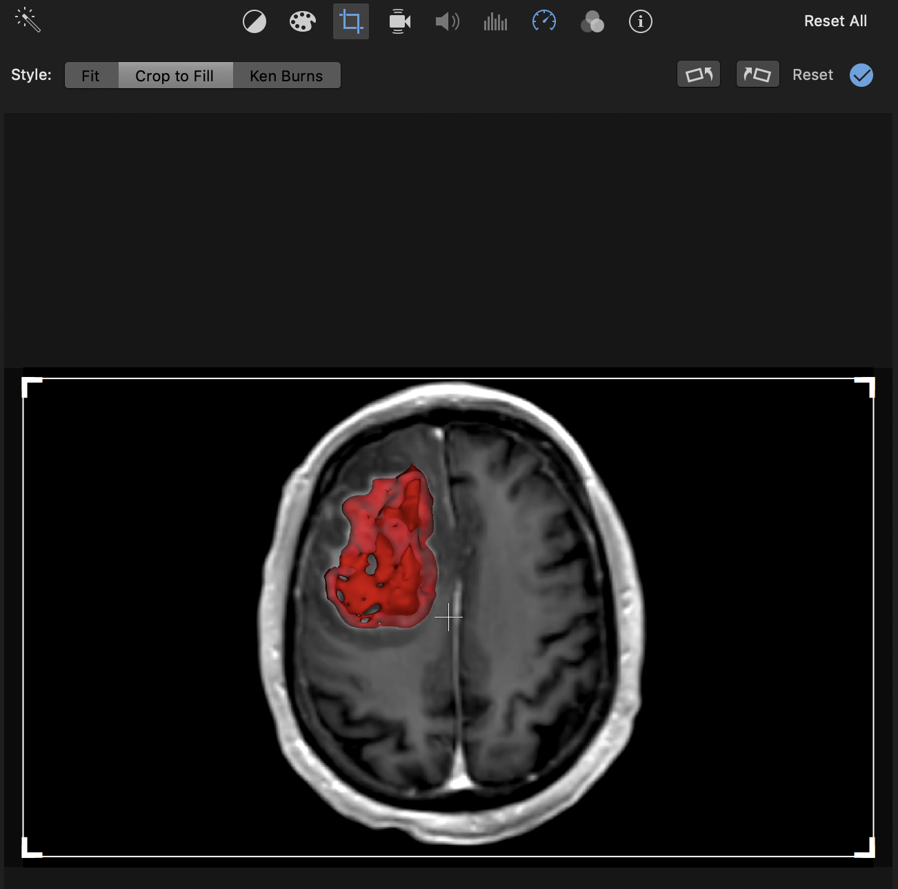

Video Speed control

Cropping/ moving video

Figure 4. Making Movies

**6.4 SLOWING THINGS DOWN**

To change the speed of the video, choose the video speed control tab shown in figure 4 and that tab is pretty self-explanatory

**6.5 TRANSITION AND TITLES**

“Titles” and “Transitions” are both independent tabs on the left side of iMovie

**6.5.1 ADDING MULTIPLE TITLES BY CREATING MULTIPLE MOVIES**

The thing that isn’t so great about imovie, is that you can’t overlap titles, so if you want to have multiple titles, you need to export one movie, then pull that movie back into a new movie and add subsequent titles, so that’s not fun but oh well

**6.5.2 THE WATERMARK**

© 2019 Mayo Clinic - Mathematical NeuroOncology Lab

**6.6 MAKING PROGRESSION MOVIES**

You’re going to want all of the ROIs to be registered to the same brain mask, since it is the same person, that only makes sense, and you have to load in all of the segmentations and the model of the biopsies. So what you would end up doing is having the brain before progression loaded, and then you’re going to open the segmentation that is the T2 after progression, and show it appearing by turning up the opacity from 0-3 stepwise and then you’ll set the original to 0 so it doesn’t look stupid, and you’ll do the same thing for the T1Gd, but you set it to 4, and then you can very clearly see the progression which is kind of cool. If there were biopsies taken, make sure you know at which stage they were taken so that you can choose the way that you are making the video accordingly.

Note: make sure that before you make your movie, everything has already been made, and is loaded into slicer, ready to be shown; try not to move the screen around too much if you want a nice video.

**7.0 HOW TO CORRECTLY SAVE A MODEL**

You should save all of the things that you are saving to a folder that is labeled for the patient so you don’t get confused because it is a bunch of files

File>save (obviously we got that much) then click all of the boxes, even though you won’t need some of them (just to be safe) because slicer likes to act up, but it won’t if we don’t give it the opportunity> change the directory to a folder made specifically for the patient’s 3D modeling stuff so that your life is easier

When you’re loading stuff back in, the thing that you really care about is anything that is .nrrd so you will drag those into slicer to get all of those individual pieces back, because sometimes if you try to reload the whole scene, slicer has an aneurysm and we don’t want that. But it’s also nice that slicer takes a screenshot of the scene so you can look and see what it is that you are about to pull up

If you make edits to the scene, you’re going to want to save all of it again and either get rid of the old stuff or put it into a new folder, which is kind of stupid, yes, but I don’t think you should really be making any modifications that need to have everything resaved, so that should be no problem, just don’t confuse yourself, helpful friendly advice from your neighborhood Jazlynn

**8.0 DOCUMENTATION/ THE FORUM**

It is very very VERY easy to get lost in slicer’s documentation, because they have so many specific things that are so similar to what you want to do, but not similar enough to help you, and you can absolutely get lost in the documentation.

To make this easier, they have a forum to scroll through! Hooray!

<https://discourse.slicer.org/>

You can send me any other questions: [langwort@usc.edu](mailto:langwort@usc.edu)

If you are having issues with slicer and can’t find things on the documentation within the first few hours of looking, ask on the forum, they are all very nice there